**Amrita Vishwa Vidyapeetham**

**Amrita School of Engineering, Coimbatore**

**Department of Computer Science and Engineering**

**Topic: Linux Commands**

**--------------------------------------------------------------------------------------------------------------------------**

**Sub Code: 19CS213 Sub Title: OS**

**Roll No: CB.EN.U4CSE19453 Name :R.ABHINAV**

**Lab: 1 Date: 18-01-2021**

With respect to a smart home imitative, we have to design an automatic water level controller with the following requirements. Overhead tank has level sensors at two different positions labeled LLS (Low Level Sensor) and HLS (High Level Sensor). Whenever the water falls below LLS, Motor should be switch on (MOut) and whenever the water raises above HLS, Motor (MOut) should be switched off. Whenever the water level remains between LLS and HLS, the status of the motor should remain in its previous state (PS) (No change in the state of the MOut). Three inputs PS, LLS, HLS and one output MOut. Derive the digital logic circuit for the above scenario, implement and test your digital design with the help of iVerilog.

**TRUTH TABLE:**

|  |  |  |  |
| --- | --- | --- | --- |
| PS | LLS | HLS | MOut |
| X | 0 | X | 1 |
| 0 | 1 | 0 | 0 |
| 1 | 1 | 0 | 1 |
| X | 1 | 1 | 0 |

**Logic equation:**

**MOut =** + (PS & $\overline{HLS}$)

**K-Map:**

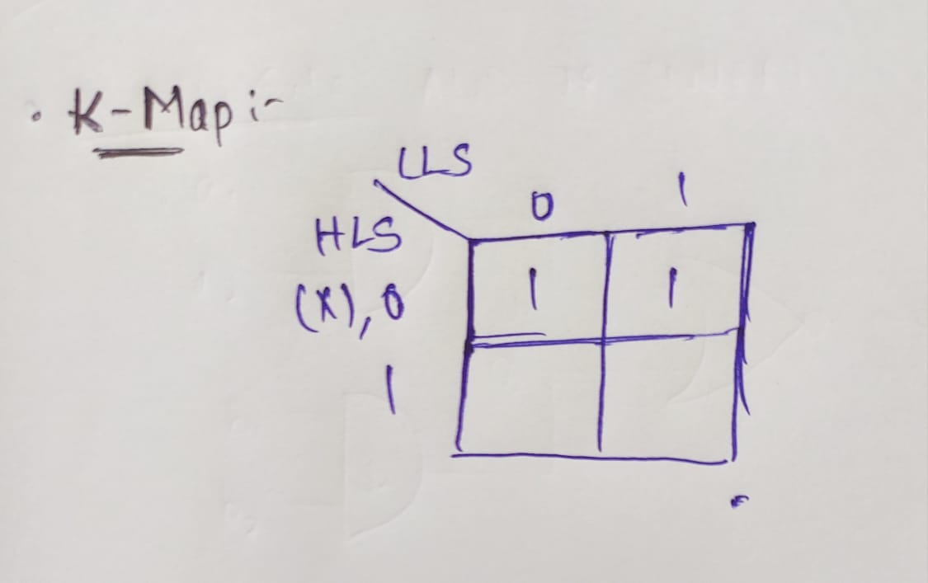

**Logic circuit:**

